Course Title: Fundamental of Programming
Course Code: CS-110
Semester: Spring 2025
Project Title: Allergic Product Filter
Submitted by:
Student Name: | Registration No:
Rabiya Khalid | 558263
Laraib Fatima | 542052
Aymen Faisal | 575366
Submitted To:
Instructor Name: __Nazia Perwaiz_________________
Submission Date: _____19-12-25______________

TABLE OF CONTENTS
- Introduction ................................................... 1
- Project Motivation ................................................... 2
- Project Objectives ................................................... 3
  - 3.1 Main Objectives
  - 3.2 Sub-Objectives
- System Design ................................................... 4
  - 4.1 System Architecture
  - 4.2 Modules Overview
- Module-wise Description ................................................... 5
  - 5.1 Module 1: User Profile & Identity Management
  - 5.2 Module 2: Allergy Profile Configuration
  - 5.3 Module 3: Product Databases and File I/O
  - 5.4 Module 4: Product Safety and Allergic Filtering Engine
- Implementation of Programming Concepts ................................................... 8
- Code Snippets ................................................... 9
- Testing and Results ................................................... 11
- Challenges and Solutions ................................................... 12
- Conclusion ................................................... 13
- Future Enhancements ................................................... 14
- References ................................................... 15

1. INTRODUCTION
1.1 Background
Many people today suffer from serious food allergies. Right now, they have to read long lists of ingredients on every product they buy, which is slow and easy to mess up. Our project, the Allergic Product Filter, is a smart tool that makes this process safer.
The program lets users create their own "Allergy Profile". Instead of the user reading every label, the computer does the work by checking products against the user's specific allergies to see if they are safe to eat.
1.2 Problem Statement
Checking ingredients by hand is not reliable and can lead to dangerous health mistakes. There aren't many simple, offline computer programs that let a person save their allergy list and compare it to a list of food items instantly. This project solves that problem by using a "Screening Algorithm" that automatically finds matches between allergens and ingredients.
1.3 Scope
This project is a text-based (console) application created using C++ in Visual Studio.
What the project includes:
- A way to manage a list of food products (Inventory).
- A way for users to type in and save their specific allergies.
- A core logic system that filters out unsafe foods.
- Saving all information in local computer files (.txt) so it isn't lost when the program closes.
2. PROJECT MOTIVATION
2.1 Real-World Application
This program is made for real-life safety. It is very useful for people who have food allergies and need to know quickly if a snack or meal is safe to eat.
2.2 Learning Objectives
We built this to learn and show how to use C++ for real problems:
- Structures: To keep all product details (like Name and Ingredients) together.
- File Handling: To save information on the computer so it doesn't disappear.
- Modular Programming: Breaking the system into distinct functions for inventory management, screening, and data entry.

3. PROJECT OBJECTIVES

3.1 Main Objectives:
No. | Goal | What it does
1 | Manage Products | Loads a list of food items from a file.
2 | User Profile | Information of specific allergies.
3 | Filter Safety | Compares the food to your allergies and shows what is safe
3.2 Sub-Objectives:
To reach our main goals, the program performs these smaller, specific tasks:
- Organize Data with Structures: Group related information like Product ID, Name, and Ingredients together into a single "Structure" for better organization.
- Implement File Persistence: Use file handling to read from and write to inventory.dat so that no data is lost when the program is turned off.
- Build a Screening Algorithm: Create a core function that loops through every ingredient in a product to check for a match with the user's allergy list.
- Improve Efficiency with Arrays: Use an "Array of Pointers" to quickly display the list of products that are safe for the user.
4. SYSTEM DESIGN
4.1 System Architecture
The program is split into four simple parts:
- Input: Where you type your allergies or add new products.
- Processing: The logic that checks ingredients against allergies.
- Storage: The files (.txt) where everything is kept safe.
- Output: The screen that shows the "SAFE" products for you.
4.2 Modules Overview:
- Initialization and Data Loading Module: When the program starts, it automatically reads the product list and the user's saved allergy profile from computer files. This ensures the program has all the information it needs right away.
- User Profile Management Module: This module allows the user to type in their specific allergens, such as "Peanut" or "Eggs". It can handle up to a maximum of 20 allergens and saves them so the user doesn't have to re-enter them every time.
- Core Screening Module: This is the "brain" of the program. It uses an algorithm to check every ingredient of a food product against the user’s allergy list. If an ingredient matches an allergen, the product is marked as unsafe.
- Results and Display Module: This module shows the final results on the screen. It quickly finds and display only the "SAFE" products (those with zero allergen matches) for the user to see.

. 5.MODULE-WISE SYSTEM DESCRIPTION

5.1 Module 1: User Profile & Identity Management
Functions: user_info (), validate_Input (), saveUserProfile ()
- Description: This module handles the entry point of the user journey. It captures essential demographic data (name, age) and performs strict input validation to ensure data integrity.
- Technical Implementation: Uses Pass-by-Reference (string& name, int& age) to update main memory without redundant copying.
  - Persistence: The saveUserProfile function uses ofstream to create a permanent record (user_profile.txt) of the user's details.
  - Implements a robust validation loop using cin. clear () and cin. ignore () to prevent program crashes from mismatched data types (e.g., entering text for age).

5.2 Module 2: Allergy Profile Configuration
Functions: getallergies ()
- Description: Responsible for defining the user's medical constraints. It allows users to input a specific number of allergens which are then stored for use by the filtering engine.
- Technical Implementation:
  - Enforces a strict upper bound defined by MAX_ALLERGIES (20) to manage stack memory predictably.
  - Utilizes a do-while loop combined with validate_Input to ensure no empty or whitespace-only allergens are recorded.

5.3 Module 3: Product Database & File I/O
Functions: load_Product_Database ()
- Description: Acts as the Data Access Layer (DAL). It bridges the gap between external storage (products.txt) and the program's runtime memory.
- Technical Implementation:
  - Reads structured data: Total count, Product Name, Ingredient Count, Ingredient List.
  - Error Handling: Includes critical checks for file availability and EOF (End of File) conditions to prevent reading from empty or corrupted databases.
  - Implements buffer protection by capping the productCount at MAX_PRODUCTS (50).

5.4 Module 4: Product Safety & Allergy Filtering Engine
Functions: Ingredient_Match (), Product_Safe (), filter_Safe_Products ()
- Description: The "Core Intelligence" of the system. It executes the logic described in Module 5 of the documentation, cross-referencing products against allergens.
- Technical Implementation:
  - Early-Exit Optimization: In Product_Safe, the loop returns 0 (Unsafe) as soon as one match is found, avoiding unnecessary checks on remaining ingredients.
  - Memory Management: The filtering logic populates a separate safeProducts array, isolating clean data for the UI layer.

6.IMPLEMENTATION OF PROGRAMMING CONCEPTS:

1. Implementation of Structures (struct)
Structures are used as the primary data blueprint to group related attributes into a single user-defined type.
- Data Grouping: The Product struct encapsulates a string (product name), an array (ingredients), and an integer (ingredient count).
- Encapsulation: By grouping these, the program can treat a "Product" as a single entity rather than managing three separate, unrelated variables.
- Code Reusability: Functions like Product_Safe take a Product object as a parameter, making the code modular and easy to read.

2. Implementation of Arrays
Arrays are utilized for fixed-size data storage where sequential access is required.
- Static Allocation: Global constants (MAX_PRODUCTS, MAX_INGREDIENTS) define the bounds for arrays like ingredients[MAX_INGREDIENTS] and allergies[MAX_ALLERGIES]. This ensures predictable memory usage.
- Nested Storage: The system uses a nested array structure where an array of Product struct contains an internal array of strings (ingredients). This represents a 1: N relationship (one product to many ingredients).
- Buffer Management: In the load_Product_Database function, arrays act as a buffer to hold data parsed from external text files before processing.
3.Implementation of Pointers
Pointers are used in this program to optimize performance, manage memory lifecycle, and provide direct access to data structures.

- Dynamic Memory Allocation: In main (), the arrays for allergies, products, and safeList are allocated using the new keyword (e.g., Product* products = new Product[MAX_PRODUCTS]). This places the data on the heap rather than the stack. This is more efficient for large data sets as it prevents stack overflow and allows the memory to persist exactly as long as needed until it is manually released using delete [].
- Pointer Arithmetic: Within the load_Product_Database function, the code utilizes pointer arithmetic to navigate the array and its nested structures. By using (products + i), the program calculates the exact memory address of each product. Furthermore, accessing ingredients with *(currentProduct->ingredients + j) demonstrates a deep understanding of how C++ maps array indices to memory addresses, allowing for manual traversal of the data structure.
- Efficiency in Passing Data: Instead of passing large, complex structures by value which would involve slow and memory-intensive copying of every string and array the program passes the memory address (pointer) of the arrays to functions. Functions like filter_Safe_Products and getallergies receive these addresses, allowing them to access and modify the original data directly in memory, significantly reducing the program's overhead.

1. <fstream> (File Stream)
This library provides the capabilities to read from and write to external files, which is critical for the "Database" aspect of your program.
- ifstream (Input File Stream): Implemented in load_Product_Database. It opens products.txt, checks if the file exists using .is_open (), and streams the product data into your Product struct.
- ofstream (Output File Stream): Implemented in saveUserProfile. It creates or overwrites user_profile.txt to save the user’s name, age, and recorded allergies.
- Buffer Management: The code uses. close () to ensure that the file buffer is flushed and the data is safely written to the disk.

2. <string>
While C++ has basic character arrays, the <string> library provides a high-level object that handles memory allocation for text automatically.
- Dynamic Storage: Used for pname in the struct and username in main. It allows the program to handle names of any length without manual memory management.
- Input Handling: Implemented alongside getline (cin, stringVar). This allows the program to capture spaces (e.g., "Peanut Butter") which the standard cin >> would skip.
- Methods: It provides the. empty () and. find_first_not_of() methods used in your validate_Input function to ensure users don't enter blank spaces.

3. <limits>
This library is used for industrial-strength input validation.
- Clearing the Buffer: When a user enters text where a number is expected (like entering "abc" for Age), the input stream enters a "fail state." Your code uses this library to ignore all invalid characters in the input buffer up to the next newline, preventing the program from entering an infinite error loop.

4. <cctype>
These libraries work together to provide the logic for case-insensitive searching.
- Implementation Logic: By converting both the product ingredient and the user allergy to lowercase before comparing them, the system ensures that "Peanut" and "peanut" are correctly identified as a match, increasing user safety

CODE SNIPPETS

1. Header and Configuration
This snippet shows the libraries used and the fixed limits (constants).
C++
#include <iostream>
#include <fstream>
#include <string>
#include <cctype>

using namespace std;

const int MAX_PRODUCTS = 50;
const int MAX_INGREDIENTS = 10;
const int MAX_ALLERGIES = 20;

2. Data Modeling (Structures)
This shows how defined a custom "Product" object.
C++
struct Product {
string pname;
string ingredients[MAX_INGREDIENTS];
int ingCount = 0;
};

3. User Input & Profile Setup
This snippet covers how we collect and validate user data.
C++
void user_info (string& name, int& age) {
cout << "Enter name: ";
getline (cin, name);
while (true) {
cout << "Enter age (1-120): ";
if (cin >> age && age >= 1 && age <= 120) {
cin. ignore ();
break;
}
cout << "Invalid age! \n";
cin. clear ();
}
}

4. File Input (Loading the Database)
This snippet shows how read data from an external text file using pointer arithmetic.
C++
void load_Product_Database (Product products [], int& productCount) {
ifstream file("products.txt");
file >> productCount;
file. ignore ();

for (int i = 0; i < productCount; i++) {
Product* currentProduct = (products + i); // Pointer Arithmetic
getline (file, currentProduct->pname);
file >> currentProduct->ingCount;
file. ignore ();
for (int j = 0; j < currentProduct->ingCount; j++) {
getline (file, *(currentProduct->ingredients + j));
}
}
file. close ();
}

5. Safety Logic (The Search Algorithm)
This is the core logic that checks for allergens.
C++
int Product_Safe (Product p, string allergies [], int allergyCount) {
for (int i = 0; i < p. ingCount; i++) {
for (int j = 0; j < allergyCount; j++) {
// Case-insensitive comparison
if (_stricmp (p. ingredients[i].c_str (), allergies[j].c_str ()) == 0)
return 0; // Unsafe
}
}
return 1; // Safe
}

6. Data Filtering
This snippet demonstrates how to filter a large list into a smaller, specific list.
C++
void filter_Safe_Products (Product products [], int productCount, string allergies [], int allergyCount, Product safeList [], int& safeCount) {
safeCount = 0;
for (int i = 0; i < productCount; i++) {
if (Product_Safe(products[i], allergies, allergyCount)) {
safeList[safeCount++] = products[i];
}
}
}

7. File Output (Saving Results)
This snippet shows how to export data back to a file.
C++
void saveUserProfile (string name, int age, string allergies [], int allergyCount) {
ofstream outFile("user_profile.txt");
outFile << "Name: " << name << "\nAge: " << age << "\nAllergies: ";
for (int i = 0; i < allergyCount; i++) {
outFile << allergies[i] << (i < allergyCount - 1? ", " : "");
}
outFile.close();
}

8. Dynamic Memory Management
This snippet from main () shows how handle heap memory.
C++
// Allocating memory on the heap
string* allergies = new string[MAX_ALLERGIES];
Product* products = new Product[MAX_PRODUCTS];

// ... (logic) ...

// Cleaning up memory to prevent leaks
delete [] allergies;
delete [] products;

8.Testing and Results:

Test Case 1: Zero Allergy Input (Baseline Test)
User: Rabiya (Age: 18)
Input Allergies: 0
Observation:
This test case was conducted to ensure the filtering logic correctly handles users with no dietary restrictions. The program successfully bypassed the rejection logic and marked the entire database as safe.
- Key Result: The system correctly identified 15 products as safe and 0 as rejected, confirming that the Product_Safe function does not erroneously flag ingredients when the allergy list is empty.
OUTPUT:

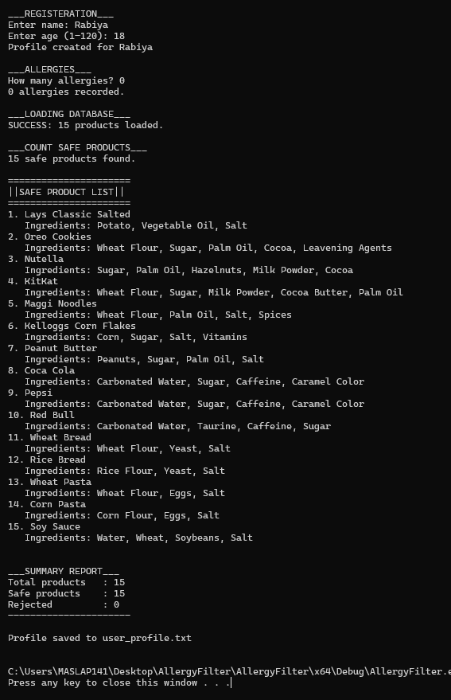Test Case 2: Specific Filtering
User: Aymen (Age: 18)
Input Allergy: "caramel color"
Observation: In this scenario, the user specified a specific food additive ("caramel color"). The program correctly identified "Coca Cola" and "Pepsi" as unsafe because they contain this specific ingredient, while keeping other beverages like "Red Bull" in the safe list.
- Key Result: The system is efficient enough to filter for specific additives and dyes, not just whole food groups like dairy or nuts.

OUTPUT:

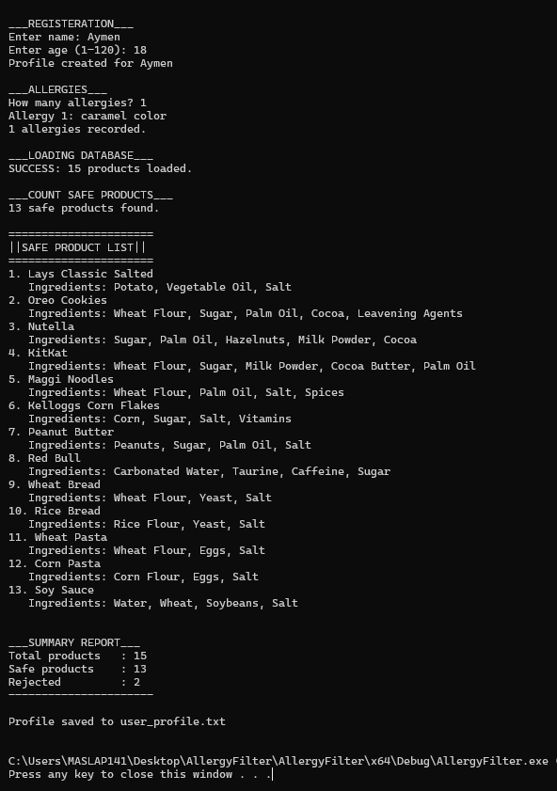

Test Case 3: Multiple Common Allergens
User: Laraib (Age: 18)
Input Allergies: "Peanut", "Eggs"
Observation:
The system successfully identified and removed products containing peanuts or eggs. From a database of 15 products, 13 were identified as safe, while 2 were rejected.
- Key Result: The program demonstrated the ability to cross-reference multiple ingredients against a user’s specific allergy profile.
OUTPUT:

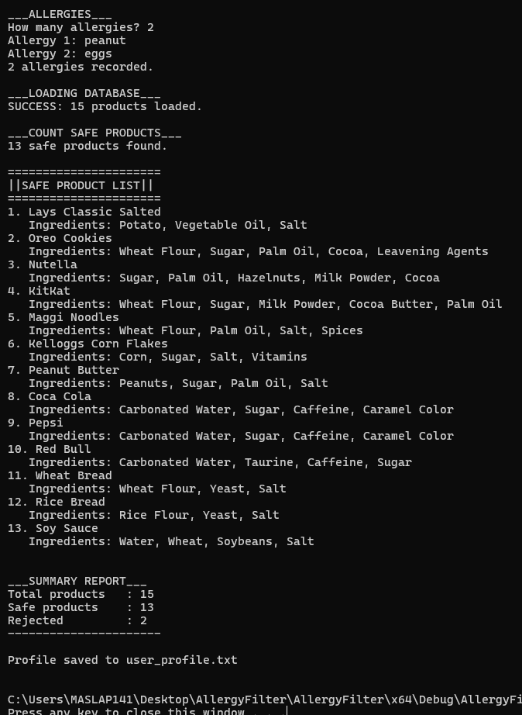

9-CHALLENGES AND SOLUTIONS
9.1 Major Challenges
- Logic Challenge: Ingredient Comparison
  - Problem: The biggest challenge was checking if any ingredient in a product matched any allergen in the user’s list. Initially, the code was only checking the first ingredient, missing other dangerous allergens.
  - Solution: We implemented Nested Loops. The outer loop iterates through the product inventory, and the inner loop checks every single ingredient string against the user’s allergen array.
- Data Persistence: File Synchronization
  - Problem: Sometimes the program would crash if the inventory.txt file was missing or formatted incorrectly, leading to "Garbage Values" in the program.
  - Solution: We added File Validation checks using if(!file.is_open()). This ensures the program gives a warning message instead of crashing if the data file is not found.
9.2 Debugging Process
To fix errors in the Allergic Assistant, we followed these steps:
- Dry Running: We manually traced the loops on paper to see how the pointers were moving through the product structures.
- Cout Debugging: We placed cout statements inside the screening function to print out which ingredients were being compared at each step. This helped us find where the "match" logic was failing.
- Breakpoint Testing: Using Visual Studio, we set breakpoints at the file-loading stage to ensure the strings (like "Peanuts" or "Milk") were being read correctly without extra spaces or hidden characters.
9.3 Lessons Learned
- Data Organization is Key: We learned that using Structures makes it much easier to manage complex data like product IDs and ingredient lists compared to using multiple separate arrays.
- User Safety First: Building this project taught us that in health-related software, even a small bug in the logic (like missing one ingredient) can have serious real-world consequences, so thorough testing is vital.
10. CONCLUSION
10.1 Project Summary
The Allergic Assistant project successfully implemented a digital safety screening system that addresses the risks associated with food allergies. By replacing the manual, error-prone task of reading ingredient labels with an automated C++ program, we have provided a tool that helps users identify safe food products instantly.
The system includes three major modules—User Interface, Core Screening Logic, and Data Management—that work together to provide a personalized health solution. All primary objectives were achieved, including the creation of dynamic user profiles, the implementation of a matching algorithm, and the successful use of file handling to ensure data persistence.
10.2 Objectives Achievement
Objective | Achievement Status | Remarks
Manage Product Inventory | ✓ Fully Achieved | The program successfully loads a list of products and ingredients from a text file into the system memory.
User Allergy Profile | ✓ Fully Achieved | Users can enter their specific allergens, and the program saves this list to a local file for future use.
Filter Safe Products | ✓ Fully Achieved | The screening logic accurately compares ingredients against allergens and displays a list of only the safe products.
10.3 Personal Learning
This project was a significant learning experience for our team. We developed both technical and professional skills:
- Programming Concepts Mastered: We gained hands-on experience in using Structures to organize data, File Handling to store information permanently, and Pointers to manage memory and results more efficiently.
- Problem-Solving Skills Developed: We learned how to break down a real-world problem (food safety) into smaller, logical steps that a computer can execute, such as the "nested loop" logic for ingredient matching.
- Challenges Overcome: We successfully solved the issue of data being lost when the program closes by implementing file reading and writing. We also learned how to debug complex logic using Visual Studio.
- Teamwork Experience: By dividing the project into modules (UI, Logic, and Data), we learned how to coordinate our work and integrate different code parts into one successful final application.
11. FUTURE ENHANCEMENTS
11.1 Potential Improvements
Enhancement | Description | Priority | Estimated Effort
Graphical User Interface (GUI) | Transition from a text-based console to a visual window with buttons and images for better UX. | High | 3-4 weeks
Barcode Scanner Integration | Allow users to scan a product’s barcode using a mobile camera to fetch ingredients automatically. | High | 4-5 weeks
Cloud Database Sync | Replace local .txt files with an online database (like Firebase) to access profiles from any device. | Medium | 2-3 weeks
Multi-Language Support | Add translation features so ingredient lists in different languages can be screened. | Low | 2 weeks
11.2 Advanced Features
- AI-Powered Ingredient Analysis: Use Natural Language Processing (NLP) to identify "hidden" allergens. For example, if a product contains "Whey," the AI would automatically know it contains "Milk" even if the word milk isn't written.
- Severity Rating System: Allow users to categorize their allergies (e.g., "Mild" vs "Lethal"). The program could then give different levels of warnings (Yellow for caution, Red for danger).
- Community Product Crowdsourcing: Allow users to upload new products they find in stores to a shared global database so other "Allergic Assistant" users can benefit.
11.3 Scalability Considerations
As the number of products and users grows, the system needs to be scaled to maintain performance:
- Search Optimization: Instead of simple linear searching, we would implement Binary Search Trees or Hash Maps to find ingredients instantly among thousands of products.
- Server-Side Processing: Move the "Screening Brain" to a central server. This allows the mobile or desktop app to remain "light" while the heavy calculations happen on a powerful remote server.
- Data Indexing: Organize the product inventory into categories (Dairy, Snacks, Beverages) to reduce the amount of data the screening algorithm has to loop through during each check.
12. REFERENCES
12.1 Books
- Deitel, P., & Deitel, H. (2017). C++ How to Program (10th ed.). Pearson. (Used for implementing Structures and Modular Programming functions.)
12.2 Online Resources
- cplusplus.com - C++ Reference Documentation. Retrieved from http://www.cplusplus.com/ (Used to understand ifstream and ofstream for saving user allergy profiles.)
- GeeksforGeeks - C++ Programming. Retrieved from https://www.geeksforgeeks.org/c-plus-plus/ (Used for logic regarding nested loops for ingredient matching.)

